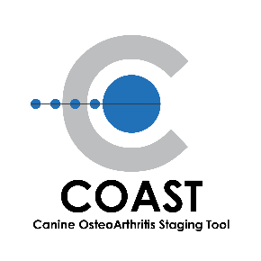
Elanco Animal Health
2500 Innovation Way
Greenfield, IN 46140

Media Contact: Corresponding Author:
Keri McGrath Dr. Duncan Lascelles
(317) 370-8394 dxlascel@ncsu.edu
mcgrath_happeks@elanco.com COASTDevGroup@gmail.com

Your Dog May Be Living with a Painful Secret
A pet owner’s guide to uncovering a common disease in dogs

GREENFIELD, IND. (October 8, 2019) - Elanco Animal Health Incorporated (NYSE: ELAN), together with the COAST Development Group, is educating pet owners on a very common and under-detected disease in dogs – osteoarthritis. Like their owners, dogs also experience pain caused by inflammation in their joints. More than one in five dogs are diagnosed with osteoarthritis,¹ but unlike humans, they can’t tell us when they’re in pain. Many dogs live with the disease getting progressively worse for years before it’s detected.²

“I always tell pet owners that osteoarthritis pain doesn’t have to be a normal part of their dog getting older. If pet owners identify subtle changes in their dogs’ behavior or movement, like a change in activity level or slowness to jump on or off of the couch, it’s time to talk with a veterinarian,” explains Dr. Duncan Lascelles, Professor of Small Animal Surgery and Pain Management at North Carolina State University College of Veterinary Medicine. “We must be our canine’s caretaker and identify the signs early. Ultimately, early detection helps your veterinarian create a treatment plan that may prevent the long-term decline of your dog’s quality of life from osteoarthritis - essentially, early detection allows us to improve the future life of these beloved companions.”

How to uncover your dog’s osteoarthritis pain:
Breed, age, high activity level, obesity and previous joint injury have all been identified as risk factors for osteoarthritis. Additionally, pet owners should monitor for signs at home and talk to a veterinarian if they notice:
- Changes in activity level
- Stiffness, limping or favoring a leg
- Difficulty standing, especially after sleeping
- Reluctance to walk, jump or climb stairs
- Whimpering in pain or protecting painful joints
The Canine OsteoArthritis Staging Tool (COAST) combines pet owner and veterinary assessments to determine the stage and severity of OA in dogs. Pet owner input is critical, as they are in the best position to evaluate the impact of OA on the dog’s quality of life at home. With COAST, pet owners and veterinarians can partner to decrease osteoarthritis pain from the earliest signs and give dogs with OA the best chance at managing this chronic, progressive disease. Over time, the tool can also help track scores to see if treatment efforts are successful.

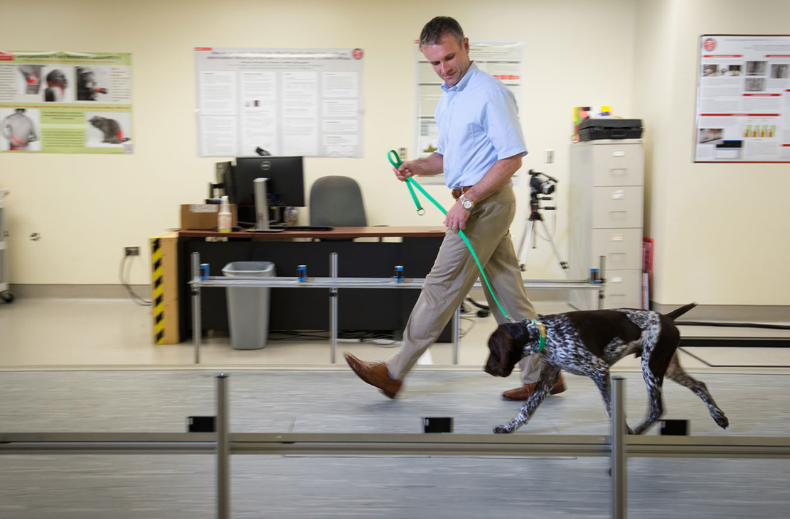
Dr. Duncan Lascalles monitors a young dog’s agility and movement. Photo courtesy of North Carolina State University College of Veterinary Medicine.

1. Johnston SA. Vet Clin N Am Small Anim Pract. 1997; 27: 699-723.
2. Cachon T, Frykman O, Innes JF, et al. Face validity of a proposed tool for staging canine osteoarthritis: Canine OsteoArthritis Staging Tool (COAST). Vet J. 2018; 235: 1-8.

About Canine Osteoarthritis
Osteoarthritis is a very common cause of chronic pain in dogs and is caused by joint inflammation. If left untreated, the disease can progressively worsen over time and cause permanent deterioration of the joint cartilage.

About Elanco
The development of COAST has been made possible by the support of Elanco. Founded in 1954, Elanco provides comprehensive products and knowledge services to improve animal health and food-animal production in more than 90 countries around the world. We value innovation, both in scientific research and daily operations, and strive to cultivate a collaborative work environment for more than 5,800 employees worldwide. Together with our customers, we are committed to raising awareness about global food security, and celebrating and supporting the human-animal bond. Our worldwide headquarters and research facilities are located in Greenfield, Indiana. www.elanco.com

PM-US-19-1566

####

